**Excel Assignment 5**

1. What is a ribbon in Excel?

Microsoft Excel ribbon is **the row of tabs and icons at the top of the Excel window that allows you to quickly find, understand and use commands for completing a certain task**. It looks like a kind of complex toolbar, which it actually is.

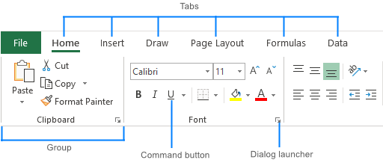

1. What is the order of operations used for evaluating formulas in excel?

When evaluating a formula, Excel follows a standard math protocol called "order of operations". In general, Excel's order of operation follows the acronym PEMDAS (**Parentheses, Exponents, Multiplication, Division, Addition, Subtraction)** but with some customization to handle the formula syntax in a spreadsheet.

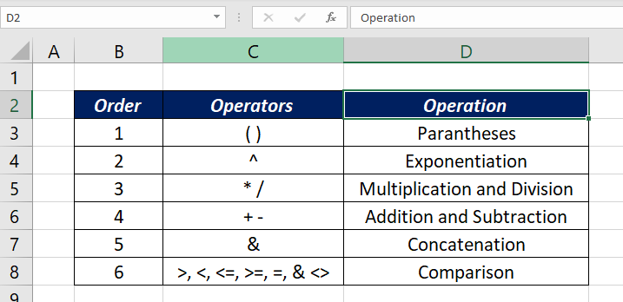

1. Reverse the string in the excel column and check whether the string is palindrome or not in the next column for each value.

|  |  |  |
| --- | --- | --- |
| **Word** | **Reverse Word** | **Is Palindrome** |
| EYE | EYE | TRUE |
| EAR | RAE | FALSE |

|  |  |  |
| --- | --- | --- |
| Word | Reverse Word | Is Palindrome |
| Mam | maM | True |
| Man | naM | False |
| Straw warts | strawwartS | True |

1. Is it possible to protect value from being copied from the cell? If yes, then how to implement it.

**Yes, it is possible**. In order to protect your worksheet from getting copied, you need to go into Menu bar >Review > Protect sheet > Password. By entering password, you can secure your worksheet from getting copied by others.

1. What is the use of Name Box in MS-Excel?

The Name Box has several functions. **It displays the address of the active cell**. It displays the name of the cell, range or object selected if this has been named. It can be used to name a cell, range or object like a chart.